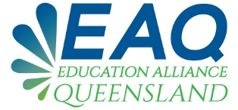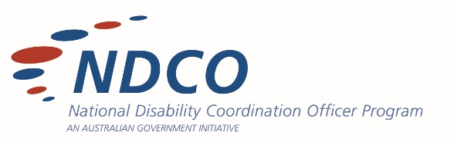

TERMS OF REFERENCE

BACKGROUND
The Education Alliance framework encompasses the education, training and tertiary sectors across Queensland. EAQ aims to improve education, training and tertiary transitions for students with disability.

The Alliance will work strategically, identifying gaps and barriers within sector stakeholders and collaboratively work to address them.

Professional development will be provided each quarter through EAQ and will be targeted and responsive. A virtual platform and face to face meetings and webinars will link Queensland stakeholders together and encourage an open environment to share and foster best practice.

PURPOSE
EAQ aims to improve transitions for people with disability to access tertiary education and training to enable positive and progressive outcomes for students with disability state-wide.
EAQ has a goal to foster the development of an effective and collaborative state network through quarterly:

- Open Forums – via face to face meetings and virtually through zoom for practical peer learning and knowledge sharing in a supportive framework for education, training and tertiary professionals and stakeholders.
- Webinars – informative, targeted and engaging.
- EAQ webpage and NDCO Qld website
- EAQ communiques

Collectively we will identify, action and respond to common issues and challenges faced by EAQ stakeholders as well as exploring and coordinating regional and state-wide actions as agreed by EAQ members.

MEMBERSHIP AND ROLE
Membership of EAQ is open to education, training and tertiary professionals and stakeholders in Queensland. Representation when appropriate will be sought from other sectors (eg employment).
The role of EAQ members is as follows:
- Collaborate and contribute within their capacity.
- Attend meetings when possible and contribute agenda items where appropriate.

- Share information and resources where appropriate with fellow members with an aim to improve education, training and tertiary outcomes for people with disability in Queensland. This may include information and resources from within their organisation/institution, as well as from other sources (regional, national and international).
- Actively participate in discussions (both face-to-face and through virtual platforms) and share their own challenges, experiences and reflections where appropriate.
- Complete EAQ surveys to assist in the provision of targeted and relevant responses.
- Maintain a safe environment in which a free-flowing exchange of ideas is encouraged.
- Disseminate information and support relationship building and ongoing action.

SHARING AND CONFIDENTIALITY
Group members should respect confidential communication. Individuals are not required to share details beyond their scope. Standard privacy principles and obligations apply and it is encouraged to de-identify case studies.

MEETINGS
- The Queensland NDCOs will coordinate and chair meetings, distribute agendas and minutes of meetings. A call for agenda items will be requested in advance of meetings.
- Meetings/Webinars will occur quarterly.
- A quorum is required to make significant decisions on behalf of the group. A quorum will exist when a majority of member organisations are represented (ie half plus one).
- A bi-annual forum will address key issues and shared learnings from across the state.

REVIEW
The Terms of Reference will be reviewed every 12 months to ensure that it is consistent with the purpose and activities of Education Alliance Queensland. Feedback/comments from EAQ members and stakeholders will be encouraged.

CONTACT
Name:

Company:

Phone contact:

Email address:

