Saving Our Silver Linings

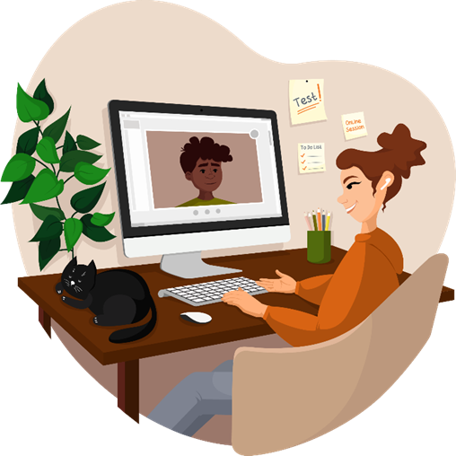
Findings from a Disability Practitioner Forum
on
How We Might Incorporate the COVID Silver Linings
Into Our New Normal

May 2021

Contents
Background 3
What Motivates our Work? 4
Our Silver Linings 5
The Enabling Factors 6
Our Dreams and Hopes 7
About our Future Work 7
About Incorporating the Silver Linings 8
Our Key Hope Themes 8
Our Designs 9
Prototype 1: Smooth University 9
Prototype 2: UDL Teaching Excellence Framework 9
Prototype 3: Assistive Tech for All 10
Prototype 4: Our Turn to Teach 10

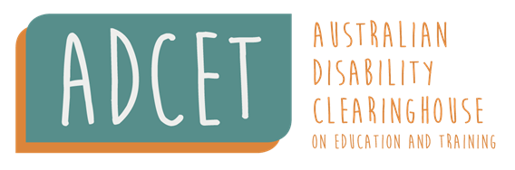

Background
During 2020 COVID-19 disrupted life for most people working and studying in tertiary education. However, a scoping survey of the impact of COVID on the Tertiary disability sector conducted by ADCET in July 2020 found that amongst the challenges, uncertainties, and difficulties some real positive shifts and changes emerged. It seems that necessity helped quickly break down some long-standing barriers and reservations. These were our silver linings, and many respondents to the survey expressed hope that the progress made towards more universal design, responding to student needs, and flexible working arrangements during this time will be part of a new way of doing things.
Therefore, an online forum was held in April 2021 to explore ways to sustain these silver linings. This forum was funded by a Strategic Funding grant from the Commonwealth Department of Education, Science and Employment to the Australian Disability Clearinghouse on Disability in Education and Training ADCET).
Twenty-five Disability Practitioners from the Uni and TAFE sector across Australia took part in the participative forum. Most of the forum activity took place in four ZOOM break out rooms. Attendees were guided by co-facilitators in each of the breakout rooms, and a Forum Workbook.
The forum drew on the strengths-based and solutions-focused Appreciative Inquiry method to:
- Discover and highlight what worked well to enable the silver linings.
- Dream and articulate hopes about what might be possible if we did more of what works well.
- Design to bring our ideas of what might be to life.

What Motivates our Work?
What Motivates Disability Practitioners to do Great Work?
Attendees shared stories about what motivated them to do great work and the common themes that emerged from these stories.
We found that what motivated Disability Practitioners to do great work is the ability to support and enable students (59%), our connections with colleagues and staff (27%) and the opportunities in the role to grow, learn and find creative solutions (14%). See Figure 1.

Some of the comments captured included:
- “Seeing the difference in the students you’re working with and seeing the impact of the service and support you’re able to provide.”
- “Able to help students feel empowered and able to self-manage.”
- “Working with Disability Champion to progress work for teachers to support students - Universal Design for Learning.”
- “Sense of having found Your Tribe to work with as a team.”
- “Sense of more than one way to do things.”

Our Silver Linings
People shared a specific example of a silver lining they noticed in their role during COVID19 restrictions and if possible one that continued as a regular practice as we return to campus.
Following are some extracts of the stories shared.
- “Automatic Speech Recognition had new value and broader application across more students, and has remained as a captioning available for the majority of students.”
- “Students having to do more for themselves in acquiring new tech skills; changed expectations: happier/easier to convince to satisfice on the short term, and review more frequently; practical and pragmatic rather than risk-averse and seeking the perfect.”
- “Internal awareness/education about the organisation's Triple A list (Alternative Assessment Arrangements.”
- “Flexible work becoming embedded into organisational culture; no longer being an application process but a given.”
- “Collaboration between different teams and having input into decision making. Broader conversation around inclusive design.”
- “Blended learning allowed students to better manage. Greater variety of options available to students.”
- “Diversity awareness training. We saw an opportunity to develop new content, less focus on face to face training. Provided an opportunity for staff to be involved in content development for the first time - I learnt a lot, gained a lot of insight. This was a valuable experience as it drew directly on people's own experience, allowing them to have a voice for themselves. Very strong positive response to the package.”
- “As a new member of the team, I found that we were doing things we wouldn't normally do - this led to expanding my knowledge base about systems and practices within the institute, in an effort to support students, 'one stop shop'. A positive and uplifting experience.”

The Enabling Factors
People determined the common factors and themes that emerged in the stories and determined their top five. These enabling factors can be classified into three different enabler categories– personal, intrapersonal and systemic – and are detailed in Table 1.
Table 1: Silver Linings Enabling Factors
Personal (from self) | Intrapersonal (from and with others) | Systemic (from systems)
- New mindsets: impossible is possible  - Adaptability  - Being flexible individually  - Looking after yourself - positive about managing own time and supporting students  - Mindset - change to a 'can do' attitude, no question of whether or not to do something, just working on doing it  - Flexibility (work/life balance)  - Self-instruction – rather than relying on campus staff  - Building student independence  - student engagement and resilience | - Increased collaboration across units and course to find solutions rather than to manage after a process in place  - Working more closely with other units or courses, earlier.  - Capacity to have conversation with colleagues across different areas - didn't need to travel to be a part of meetings  - Engagement and connection of students was positive  - Engagement from senior staff with student experience at the heart of the decisions that were made  - Collaboration | - Specific new units that work across units eg online exams  - Letting go of the formality - cutting through the red tape  - Being flexible as an organisation  - Trust - trusted by organisation to do their work, trust in people's work ethic  - Prompted to revisit guidelines and change perspectives  - Approaches to Universal Design for Learning  - Working flexibility and blending options that were not previously implemented  - Overall learning practices for staff  - Having enabling Policy and parameters - once new processes had been established, a pathway to continue was made  - Flexibility (work/life balance)  - Increased flexibility of academics - exams can be online, an oral assessment was possible

Our Dreams and Hopes
People shared their hopes and dreams of what might be possible within their role if their University or TAFE were able to draw on these silver linings enabling factors to create better experiences for staff and students.

About our Future Work
We hope that our future work:
- Others take our role on board
- Has a big-picture focus with less administration
- Continues to be meaningful and effective
- Has reduced caseloads and more time with students
- Provides more balance and flexibility for personal and work life
- Means we have the capacity to work with staff on bigger picture things
- Allows us to shift our role from direct service to students to capacity building with staff as more UDL means less students need to disclose
We hope that:
- Students are empowered and have more flexibility
- Students have choice and control over their learning experience
- Students are empowered and have more flexibility
- Students are earning and learning
- People are flourishing and being supported to reach their goals
- People are thinking outside the box - looking at the variety of learners and the different ways people engage with new information
We hope that our campuses:
- Are proactive as the baseline has been raised
- Are vibrant, re-energising and connected places
- Are more accessible and have more Universal Design Learning
- Have greater accessibility of websites and inclusivity of courses
- Provide an array of assistive software

About Incorporating the Silver Linings
The shared hopes about what our Unis and TAFES might do differently to keep and incorporate more of the silver linings into the new normal.
- Less systems and they are more interconnected - seen as one system
- Not forget the lessons from Covid- Keep the momentum going to think outside the box
- Blended methodology that allows for choice and control over individual learning, without losing human connection
- Hybrid model and UDL is the new normal (Revise Disability Action Plans / Revisiting existing perspectives/priorities)

Our Key Hope Themes
- Collaboration
- Connection
- Meaningful work
- Empowerment
- Inclusion
- Enabled
- Universal design
- Unique
- Flexible work environments
- UDL is embedded and embraced
- Hybrid teaching and learning model enabled through technology

Our Designs
Each group developed one hope about the future into a rapid prototype design. Following are the four protype designs as presented by each of the groups.

Prototype 1: Smooth University
How would this work?
- One system (or nearly only one) fundamentally supporting student capacity building and not just getting through a degree/course. There is stream-lined student support and standard processes that are linked together.
- It flags the connections that need to be made (and only those - privacy and confidentiality considerations incorporated).
- Students are able to see the moving parts and learn the communication required from effective management of processes, rather than just expecting all the moving parts to fit together. Opt-out services: need to engage enough to consider if appropriate for you and make a conscious, somewhat informed decision to opt-out.
Why is this important?
- It's proactive and focussed on developing the capacities of students, not just relieving pressures on staff in isolation.
Who does it?
- Needs a unit/person designated for Pulling This Shit Together [With Covid Speed]!
What’s the next step?
- Get top-level buy-in!!! Student -retention as the leverage point.
- Pilot with first year students.
- Make it explicit that the point of coming to uni /TAFE is to build your capacities, through coming to uni/TAFE, for managing your interface with unis/TAFE and with the people within uni/TAFE (staff and other students).

Prototype 2: UDL Teaching Excellence Framework
How would it work?
- Online UDL module with UDL basics/foundations and case studies to equip teachers. Include learning outcomes and achievements so that they are measurable / Bench-marked model/process adapted for other institutions.
Why is it important?
- Teachers can have a central source of content for UDL resources / community consultation / co-design with people with lived experiences is important in order to implement the model for this centralised learning.

Prototype 3: Assistive Tech for All
How would this work?
- Embed assistive technology into existing platforms, for example Text-to-Speech and Automatic Speech Recognition functions.
- Will need to include digital literacy as part of student orientation to ensure students know how to use the technology. (Digital literacy Coaches provided to all students).
- Academics should also be trained on it and using it themselves to assist in their own work but also to better understand the student experience.
Why is this important?
- It will increase the accessibility of content for all students including international, students with disability, ESL students, and learners with literacy difficulties.
- It will increase retention, and it will increase numbers and it will increase profit.
Who does it?
- The project would bring in different relevant areas of the University and or TAFE- academics, Teachers, IT services, student orientation programs, Disability services, course design areas.
What’s the next step?
- Secure commitment from the federal government to fund a central project who can get this happening across all universities Australia wide.

Prototype 4: Our Turn to Teach
How would this work?
- Scheduled time within the working week where students with disability lead sessions to deliver to staff, about what they want people to hear/learn to increase awareness and understanding around their condition.
- Topics to be decided by the students, supported by someone to coordinate, scheduled questions, invitations for questions ahead of time to be answered anonymously in the sessions/ or built into session content.
Why is it important?
- Supports the principle 'Nothing about us without us'.
Who does it?
- Co-design - questions/feedback/comments invited from attending participants.
What is the next step to make it happen?
- To move from design to implementation we need expressions of interest from students - via DLO's/DA's.

