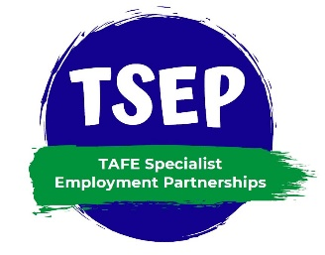

TSEP Consultant Induction Letter

Dear ………….
Welcome to the TAFE Specialist Employment Partnerships program (TSEP)!
You have joined an enthusiastic national network, made up of several different partnerships, keen to improve employment outcomes for graduates who are living with disability.
This Induction pack has been designed especially for you and should help ease the transition to this new and exciting role.
The most important thing to remember currently is that there is plenty of support available.
The TSEP program is an NDCO Initiative and they have established a national network to help and guide you, your organisation and your TAFE.
Add this link to your favourites:
https://www.tsep.com.au/
A TSEP consultant handbook is attached for your information. This covers topics including an overview, a checklist for your first 3 weeks, tips on approaching large employers and much more.
A copy of the Partnership MOU is attached, as this includes important information about this partnership, and helps to clarify expectations and roles.
Your organisation's logo will be uploaded to the TSEP website to demonstrate the partnership and any help you can provide in connecting with your marketing team is most appreciated.
We need various formats including PNG Format with transparent background.
This will assist in the development of information and marketing material as well.
TAFE will arrange regular meetings to ensure that the partnership progresses and to iron out any bumps.
These meetings are crucial, and we look forward to engaging with you, either face to face or electronically.
We look forward to working with you on this exciting program!
Regards,
TAFE Contact Details

