Advice about navigating university with disability
We asked students with disability to share what they wished they had known when they started university. The responses, as described here, hold valuable advice for future students on how to navigate their university journey. This document also poses reflective questions that will help students better prepare themselves for university.
This resource is for anyone thinking about going to university who is neurodivergent,
has a mental or chronic health condition or physical disability and who may have
additional needs during their studies.

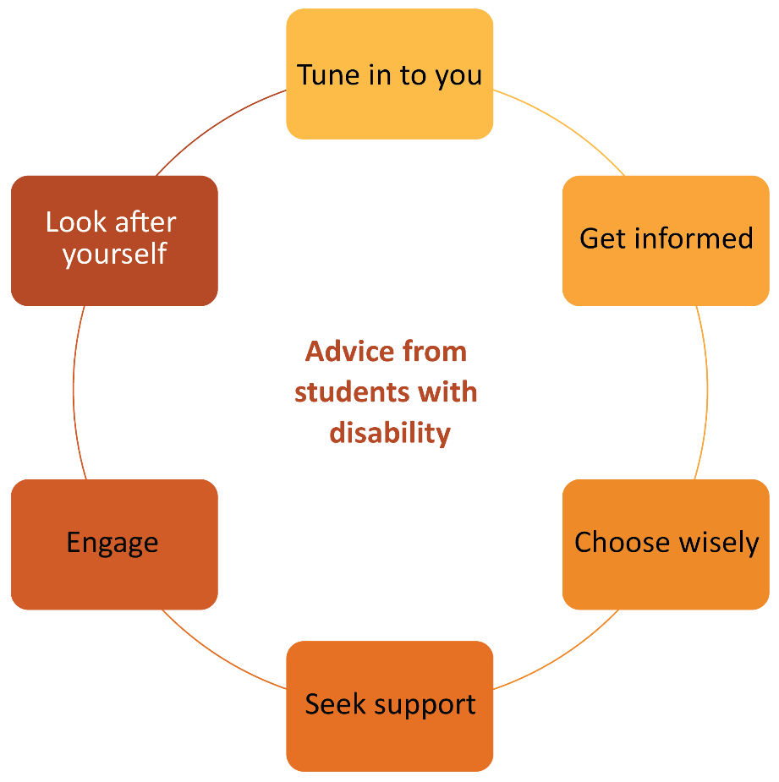
1. Tune into you
Take time to understand yourself – your aspirations and goals as well as your strengths and limitations. Ideally, you’ve been doing this for many years, but if you haven’t, then actively “tuning in to you” is important before you decide on a course of action.
I would ask myself, is this the best use of my time? Why am I enrolling? Can I gain my goals without doing university study? (Uni student #167)
Talk to someone at the university to review your choice of course in order to best serve your end goal. (Uni student #95)
During your tuning-in process, it might be useful to question what is influencing your aspirations. Tuning in to you is an opportunity to explore whether anything (e.g. others’ negative attitudes towards disability) is limiting your goals for yourself.
Of course, the decision you make now about your future career is not fixed – it is predicted that the average young person will have 17 jobs over 5 different careers in their lifetime.
What is important is that whatever you choose to do fits in with your goals at this precise time. Our respondents explained:
it is okay if you change courses or do not enjoy what you are studying and would like to change to another degree. And stick to what you enjoy the most!
(Uni student #148)
Top Tip!
Take a quiz to find a list of occupations tailored to you. Discuss your findings with a career development practitioner.
Tuning in to you might mean taking some time off between finishing school and starting university to understand exactly what you are interested in. Did you know that approximately a quarter of students take a “gap year” between school and university, using this time to understand exactly what they wish to do next?
Top Tip!
Take what you’ve discovered and speak with a career development professional about it – in your high school, vocational institute (e.g. TAFE NSW) or state government service (e.g. Service NSW or Jobs Victoria).

Questions to consider:
- What are my strengths and interests?
- What is my motivation to study?
- If there were no barriers, what kind of work would I choose?
- What would I like my work to mean?
- What skills am I interested in learning and where would I like to use them?
- What kind of people would I like to work with?
- What is it about me that makes me good at these things, or makes it possible for me to be good at these things?
- Am I comfortable explaining what I need to a future employer so that I can perform best in future roles?

2. Get informed
Before you commit to a course of study, take time to research, ask questions and get informed about pathways into the job or career that you desire and the skills and qualifications that might be needed.
I would have researched the discipline better as I now feel a counselling degree would be more suited to my career path. I didn't realise psychology was highly research based. (Uni student #134)
Top Tip!
Ask your local university (or university of choice) whether they offer enabling or foundation courses to help you prepare. This pathway is a supportive one for
many students.
There are many pathways into and through higher education. Enabling courses, TAFE (Technical and Further Education) and short courses can allow you to experience your subject content before embarking on a longer course of study. Some people decide to use these options to build literacy, numeracy or study skills to help them become better prepared to enter their chosen course.
Consult with a career development practitioner about the job or career that you want to obtain and the skills and qualifications that you will need for that role. Investigate the different courses and subjects that are compulsory or “requisite” and map out a pathway, including backup plans. Also be aware that it’s common to have many jobs across several sectors across the lifespan and that what you thought was your goal may not be where you end up.

I would tell myself to look at every avenue and requirement post the degree you’re about to enrol in, such as will this degree take you where you want to go or do you need to do more studies. If so, what are they and how do you get there?
(Uni student #13)
Investigate the range of modes of study – full time, part time, face to face, distance or combined. You can even enrol in subjects from multiple universities and construct a course of study that way.
The other advice I would give is to do online studies … I didn't realise the benefits of online study when I first enrolled as there was not a lot of information on it.
(Uni student #40)
Some students find on-campus studies suit them best and others prefer online study. A combination of the two is also possible.

Questions to consider:
- What qualifications are required for my chosen career?
- What are the different pathways (e.g. enabling courses, vocational education and training or other tertiary studies) into and through those qualifications?
- What study options are open to me? Can I choose on-campus, distance or hybrid study modes? Can I access the support of a Regional University Centre? Are there full-time, part-time or individualised subject progression options available? What are the pros and cons of each for me?
- How can I access reasonable adjustments for my course, and how might these translate into workplace adjustments for my chosen career?
- Where can I find information to help me with this (e.g. JobAccess), and what are the registration requirements, if any, for my chosen career?
- What are the requirements for work integrated learning? Can this be completed part time? Or is full time a requirement for the course? And is it an inherent requirement or just an administration preference of the school or registration body?

3. Choose wisely
Before you start, and as you progress through your education, choose your institution, course and subjects wisely. Students suggest investigating the academic and social supports provided by each of the universities as well as the outcomes achieved by their graduates.
Pay attention to how they’re socialising you into being ‘a student’ and also ‘a future [course outcome]’ because this is useful information in deciding if they’re the uni right for you. (Uni student #141)

Top Tip!
Explore the websites of the universities you are considering attending. The services and benefits offered are explained under the section generally called “future students”.
Along the journey, current students with disability advise maintaining a focus on the subjects that are essential to career goals and the chosen pathway.
My piece of advice would be to really look at what your career goals are before you start. Take time if you need to before enrolling to ensure the degree you've chosen will actually help you achieve your goals. (Uni student #33)
Top Tip!
Make an appointment to speak to the relevant course coordinator or go to the student service area and ask what subjects you can do.

Questions to consider:
- What are the graduate outcomes for students in my course/career through my intended university?
Top Tip!
Explore and compare institutions and study areas based on real-life experiences of students. Use the Australian Government’s ComparED website.

4. Seek support
Once enrolled in your course of study, take the time to explore the resources that are available to you. Universities want students to succeed, and they provide support through online information and resources as well as via access to support services. Each university has a career development learning unit that can help you examine your choices, clarify emerging dilemmas (if any) and develop your understanding of your preferred areas of work and how you might fit yourself into them. The unit can also offer support with obtaining professional experience, applying for graduate jobs and career planning.
Top Tip!
Once enrolled, connect with your university’s careers unit – make an appointment, and subscribe to their newsletter

I would have told myself to take the time to really understand the amount of resources available through the uni. The website is so huge. I still don’t think I have explored everything there is as yet. (Uni student #28)
Current university students with disability advise new students to seek out support from the university disability service early in their course of study, or ideally before the course commences, so that reasonable adjustments are in place from the start. Universities have broad definitions of disability, which include mental health conditions, learning conditions and chronic health conditions.
Top Tip!
Make an appointment to speak to someone in disability/accessibility services about what you might need to support your success.
My advice would be to ensure you let your university know how they can best support you with your disability so you have a level playing field. I never looked back. I would again, if I went back in time, ensure that I took this step. (Uni student #98)
Students with disability can request flexibility in assessments, the use of assistive technologies, in-class support and other academic support such as mentors and considerations for professional experience and fieldwork.
It's so important to reach out for help when you need it. Uni wants you to do well and if you ask for it, help will always be given. (Uni student #55)
Other students are also fantastic sources of support. Engaging with your peers and forming friendships are important activities that help create a network of people from whom you can receive the assistance, encouragement and support required to succeed at university.

Questions to consider:
- What arrangements do I need to do my best at university? What support units are available at my university, and what resources do they have?
Top Tip!
Search your university’s website and contact the learning support/academic skills, and disability or accessibility/student access and equity services.

5. Engage
Consult and work with other students, academic staff and support units towards your academic success and to obtain skills in preparation for graduate employment.
I think one of the most valuable suggestions I could offer is to engage and work with the teaching staff as soon as possible to develop adaptive skills before the units where they are needed – and more importantly, for your future career. (Uni student #151)
I should also be open to consulting with other students and academic advisors when designing my degree so that it suits me and my study pattern. (Uni student #97)
Engaging is about being proactive – seeking out information, asking questions and gathering support. Consulting with and learning from others is what most professionals do. It’s a mandated competency in many professions. Students suggest that thinking ahead and asking about supports before such things as work placements and fieldwork occur might safeguard career development outcomes.
Ask questions and investigate:
- Will you allow extra time and support for certain courses?
- Can you ensure that if something happens to me, I will be able to complete course work, especially in field work, if it has to be delayed?
- If you know you cannot support me, please advise me before pushing me into taking classes to complete a course where I cannot get adequate supports. (Uni student #84)
Engaging with other students and staff at the university also makes it enjoyable. The social aspects of university are some of the most rewarding, helping us all to succeed. The friendships and networks made at university often endure for many years and bring richness to our lives.

Questions to consider:
- Who can help me get what I need to succeed at university? Who are the other students, academics and professional staff that I can talk to, network with and engage with?
Top Tip!
Introduce yourself to your lecturers and tutors and let them know your strengths and learning needs.

6. Look after yourself
Look after your health and pace yourself. Current students’ advice to incoming students relates to having realistic expectations about what you can manage and achieve given your own health and circumstances.
I would say to my past self, that if uni is not 100% for you, you are still credible if you spend a semester at TAFE or do your whole education through TAFE.
(Uni student #50)
Looking after yourself involves taking on only what you can cope with, being gentle on yourself about that and not comparing your journey to that of others.
I would tell myself not to be anxious about trying to compete with others and being the best …
I put myself through subjects that I thought would achieve [being the best] – resulting in a pass and a mental illness. (Uni student #50)
Top Tip!
Read each subject outline carefully and know how much time and work is expected so you can enrol in a study load that’s suitable for you.
Only 60% of students go straight from school into university and then employment, and these students are mostly from metropolitan and mid- to high-socioeconomic backgrounds. Even then, these students take three to five years to complete an undergraduate qualification, so there isn’t one ideal or perfect journey.
Be kind to yourself, and don’t waste energy comparing your study experience to others (everyone’s experience is unique); give yourself a break if you don’t achieve the grade you expected. Learning is like life – ups and downs – and that it’s ok, just keep going. (Uni student #57)
Top Tip!
Find out the CENSUS DATE for each session. It will be listed on the “key dates” page of the university website.
Find out the census date for each university session. The census date is the last date that you can withdraw from subjects without paying for them. After this day, the cost of the subject will be added to your account.
Also find out the last date that you can withdraw from subjects without academic penalty. Prior to this date, you can withdraw and have the subject deleted from your academic record. After this date, if you do not meet the minimum requirements, you will receive a fail grade. Getting too many “fails” can put access to a Commonwealth supported university place at risk.
Knowing when these deadlines are means that you have more control over the cost of university and the grades you receive if you encounter health, personal or academic problems.

Questions to consider:
- What study load can I manage and still maintain good physical and mental health?
- What study load best balances with my other commitments (e.g. family, work)?
- Where can I find out more information about useful self-care strategies, organising my time and prioritising my study/life balance?
Improve your chances of a successful journey through university into a career by following this advice from current students with disability:
- Tune in to you
- Get informed
- Choose Wisely
- Engage
- Look after yourself

Source: 2020 survey of higher education students with disability. Full reports available at https://www.ncsehe.edu.au/publications/persons-disabilities-higher-education/ and https://www.ncsehe.edu.au/research-students-disability-careers/

