What do university students with disability want from employers and the workplace?
When university students with disability were asked what they were seeking from an employer, they identified five core characteristics of the workplace or the employer that are valued. This document briefly describes those characteristics and poses reflective questions that employers should ask of themselves to better understand the level of inclusivity within their workplace.
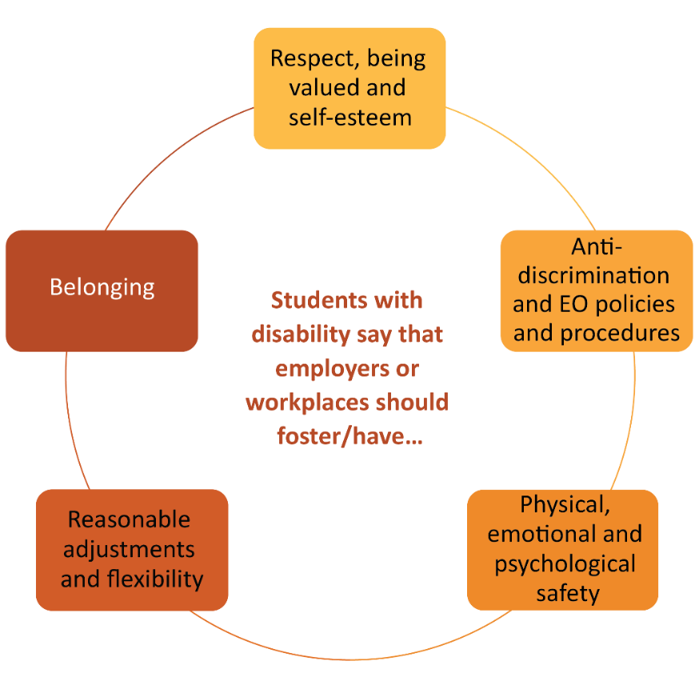

Respect, value and esteem
Graduates with disability want:
- opportunities to work, like everyone else
- workplaces that are supportive, understanding and enjoyable to work in
- to work with people who appreciate them for their abilities and contributions
- to be recognised for their individual strengths and limitations, like everyone else
- employers to be open to communication about needs and supports
- employers to ask about needs and supports if they’re feeling unsure
- to be part of a workplace where they can contribute to the success of the business/organisation
- to be part of an organisation where their disability is seen as an opportunity to better understand and meet the needs of a diverse customer base.
Graduates with disability don’t want:
- to be patronised or made to feel “special” because of their disability
- to be stigmatised or excluded because of their disability.
I wish employers knew more about [my condition] so that [they] could
understand my strengths.
University student with disability

How can I make this happen at our organisation?
- Do we support our employees (e.g. through training or induction) to gain awareness, confidence and sensitivity to people with disabilities, their rights and the barriers they face in gaining and retaining employment and building careers?
- Is our recruitment process well designed so that there are multiple ways for candidates to demonstrate their capacity to do the role?
- Do we have reasonable adjustment processes ready and visible?
- Are our recruitment policies and practices inclusive and accessible?
- Is training and induction accessible (e.g. subtitles, screen-reader friendly)?
- Do we foster and encourage an inclusive workplace environment?

Practices, policies and procedures
Graduates with disability seek:
- employers who have clear policies and procedures to support anti-discrimination and equal opportunity practices
- processes in place to ensure that the organisation is compliant with all relevant legislation
- practices that underpin respect, safety, support and belonging.
[I desire] employment that will acknowledge that I have a physical disability
but not limit my career prospects because of it.
University student with disability

How can I make this happen at my organisation?
- Does my workplace understand the relevant anti-discrimination and inclusion legislation?
- Do we have an inclusion and diversity policy that is visible and easily accessible to all employees?
- Do we actively hire and promote for diversity?
- Do we have discussions with our employees about any accommodations or other workplace practices that may assist our employees to work most productively?

Safety
Students with disability, like all employees, require physical, emotional and psychological safety when it comes to applying for and commencing a new job.
Not all disabilities are visible – workplaces need to be safe and supportive for diverse workers, and their needs, regardless of whether disability is disclosed.
I don't want to be treated like the sick/crazy person (I get that a lot once people know),
but it's also horribly isolating pretending to be someone else just to
fit in/feel safe at work because of the stigma.
University student with disability

How can I make this happen at my organisation?
- Is our workspace flexible to accommodate a wide range of preferences, skills and abilities?
- Is our workplace designed to be easy to use, efficient and comfortable without unnecessary effort?
- Are spaces designed to be accessed and used regardless of an employee’s size, mobility or tolerance to fatigue, noise, light and distraction?

Support
Students with disability require reasonable adjustments and flexibility from their employers so that they can participate in the workplace on an equal basis to their colleagues.
Employers need to understand what reasonable adjustments are in the workplace and ensure they can provide them for employees who disclose disabilities.
Having flexibility, support and understanding so I can apply and develop my skills as well as be a functioning member of the workforce.
University student with disability
How can I make this happen at my organisation?
- Do we have processes and procedures in place to assess and deliver reasonable adjustments to a person’s workplace, where required?
- Are we progressively moving towards a more Universal Design (UD) approach to our workplace, where the need to provide reasonable adjustments becomes less likely over time?
- Do we know where and how to access professional expertise on reasonable adjustments and UD in the workplace if needed?
- Do we schedule regular conversations with our employees to determine whether the adjustments made are beneficial or whether there are more suitable adjustments possible?

Belonging
Like everyone else, people with disability want to fit in and be accepted for who they are.
People with disability seek organisations with good work cultures, mentoring programs or other opportunities to further develop industry skills.
My fit into the industry I work in is the most significant factor for me. I try to not let the disability factor into significant decisions like this.
University student with disability
How can I make this happen at my organisation?
- Do we make new employees feel welcome? Do we host activities that build connection and friendship?
- Do we have a mentoring or induction program for new employees that consciously considers issues of diversity and equity?
Employers, can you better support students with disability in your organisation and workplace through:
- reasonable adjustments and flexibility
- respecting, valuing and promoting the self-esteem of employees
- fostering a sense of belonging
- providing for physical, emotional and psychological safety of employees?

Source: 2020 survey of higher education students with disability. Full reports available at https://www.ncsehe.edu.au/publications/persons-disabilities-higher-education/ and https://www.ncsehe.edu.au/research-students-disability-careers/
Note that these attributes were identified by the 170 participants in one survey and may not represent the views of all students with disability.

