Supporting Students with Disability in Vocational Education and Training (VET)

Introductory Guide

Contents

Introduction 3

Access and equity in vocational education and training (VET) 3

Access and equity principles 3

Inclusive education practice 3

Accessibility, usability and UDL 4

Inclusive educational practice and the rights of students with disability 5

Supporting Students with Disability in VET Toolkit 8

Toolkit resources 8

Glossary 10

Resources guide 12

Key references 12

DSE fact sheets 12

Disability Awareness e-Learning platform 12

# Introduction

## Access and equity in vocational education and training (VET)

The [Standards for Registered Training Organisations (RTOs) 2015 (Cth)](https://www.legislation.gov.au/F2014L01377/latest/text) (Standards for RTOs) outline the responsibility of providers to adhere to the principles of access and equity.

Access and equity means policies, procedures and practices aimed at ensuring that vocational education and training (VET) is responsive to the individual needs of all clients, including those whose age, gender, cultural or ethnic background, disability, sexuality, language skills, literacy or numeracy level, unemployment, imprisonment, or remote location may present a barrier to access, participation and the achievement of suitable outcomes.

**Please note:** RTOs registered by the *Victorian Registration and Qualifications Authority* or the *Training Accreditation Council Western Australia* may refer to the following websites for requirements specific to you.

[Victorian Registration and Qualifications Authority](https://www.vrqa.vic.gov.au/VET/Pages/default.aspx)

[Training Accreditation Council Western Australia](https://www.wa.gov.au/organisation/training-accreditation-council/training-accreditation-council-regulatory-framework)

## Access and equity principles

Access and equity principles include:

* equity for all people through the fair and appropriate allocation of resources
* equality of opportunity for all people without discrimination
* access for all people to appropriate quality training and assessment services
* increased opportunity for people to participate in training.

## Inclusive education practice

According to the United Nations, inclusive education:

* recognises individual learner strengths and capabilities
* accommodates individual learner requirements
* commits to removing barriers to participation.[1]

Inclusive education requires VET providers to create meaningful, welcoming and engaging learning environments. It means designing, developing and delivering curriculum to reduce barriers and ensure that all learners have a fair and equitable learning experience.

Inclusive education is not achieved by ticking a checklist. Instead, we achieve it through intentional design and practice. Principles of accessibility, usability and Universal Design for Learning (UDL) support an inclusive education and training approach for all students.

## Accessibility, usability and UDL

When talking about inclusive educational design, we often talk about accessibility and usability. Accessibility is about addressing specific barriers for students with disability. Usability is about designing in a way that addresses a wide range of needs and preferences. Improving accessibility often improves usability. Together they create a more inclusive approach that benefits everyone.

When we add UDL, we acknowledge that there is no 'typical' or 'average' learner. We all learn differently because of our diversity and variability, including disability. Greater flexibility in teaching and learning practice helps engage and support all learners to succeed.

In simple terms, UDL means:

* universal – ensuring all learners can participate, understand and learn.
* design – ensuring we design, develop and deliver accessible training and assessment strategies (curriculum) for the broadest group of learners possible.
* learning – incorporating into curriculum design *what* a student needs to learn to do, *why* they need to learn it and *how* they can learn it.

UDL comprises good curriculum design, development and delivery. It can offer many benefits.

For learners, benefits include:

* a curriculum and learning environment that allows them to learn in a way that aligns with their strengths, needs and preferences
* greater independence (balance between independence/interdependence) and self-efficacy (ability to cope and manage)
* empowerment through variety and choice in the curriculum
* less need to share information about their disability
* less demand for specialised support services, which some learners may find stigmatising
* less need for reasonable adjustments or special provisions
* a strengths-based approach
* increased equity
* increased motivation to learn
* more understanding of their learning style
* better outcomes by elimination of barriers.

For trainers and assessors/RTOs/other tertiary providers, benefits include:

* less need for individualised supports and associated costs
* more time to focus on high-value learning
* better learning outcomes for all learners
* increased engagement and learner retention
* enhanced reputation
* a culture of inclusion.

## Inclusive educational practice and the rights of students with disability

The [Disability Discrimination Act 1992 (Cth) (DDA)](https://www.legislation.gov.au/C2004A04426/latest/text) makes it unlawful to discriminate against people with disability and their associates based on disability.

The [Disability Standards for Education 2005 (Cth) (DSE)](https://www.legislation.gov.au/Details/F2005L00767) set out the standards education providers must comply with to achieve the objectives of the DDA. Each of these standards deals with different aspects of education and training.

The DSE gives students with disability the same rights as other students. Students with disability should be treated with dignity and respect. They should be able to enjoy the benefits of education and training in a supportive environment that values and encourages participation by all students.

To achieve this, the DSE gives current and prospective students with disability the right to education and training opportunities on the same basis as students without disability. This includes the right to comparable access, services and facilities, and the right to participate in education and training without discrimination.

### What does this mean for RTOs?

RTOs have an obligation to comply with all legislation that is relevant to the services they provide. Clause 8.5 of the Standards for RTOs requires RTOs to comply with Commonwealth, state and territory legislation and regulatory requirements relevant to their operations. Although not specifically stated under Clause 8.5, this obligation includes compliance with the DDA and DSE.

Under the DSE, RTOs have obligations at all stages of the learning journey including:

* enrolment
* participation
* curriculum development, accreditation and delivery
* prevention of harassment and victimisation
* provision of student support services.

Examples of how providers can meet these obligations include:

* course planning and development that considers the potential needs of students with disability and identifies ways to incorporate empowering and enabling learning and assessment strategies
* inclusive enrolment practices
* professional development for all staff in the organisation
* access and equity policies and procedures
* relevant and accessible services and facilities for all
* a clear and fair complaints process.

### What does this mean for trainers and assessors?

Trainers and assessors need to be suitably current and competent in their practice to provide training and assessment that is inclusive and empowering for all learners.

### What is ‘building capability’ and why is it necessary?

Capability building refers to developing the skills and knowledge required for tasks. In this case, it is about RTO staff, trainers and assessors building knowledge, understanding and skills to support students with disability and being able to confidently apply the requirements of the DDA and DSE.

Capability building does not have to happen overnight; it requires continuous focus. RTO staff, trainers & assessors can start small and then continue to build. It involves active learning; where knowledge, understanding and skills are developed, practised and applied.

Actions will not always be correct; however, it is important to continually build capability to improve and grow inclusive training and assessment environments, practices and experiences.

There are many ways to do this, including:

* free e-Learning opportunities e.g., [disabilityawareness.com.au](https://disabilityawareness.com.au/)
* training and webinars (free and paid) through key training organisations such as ADCET, Victorian Development Centre (VDC), Velg Training, VETR
* building a network within the organisation
* participating in external networks
* adding inclusive approaches as an agenda item in team meetings
* having a resource bank
* mentoring and shadowing.

**Figure 1: The student learning journey**

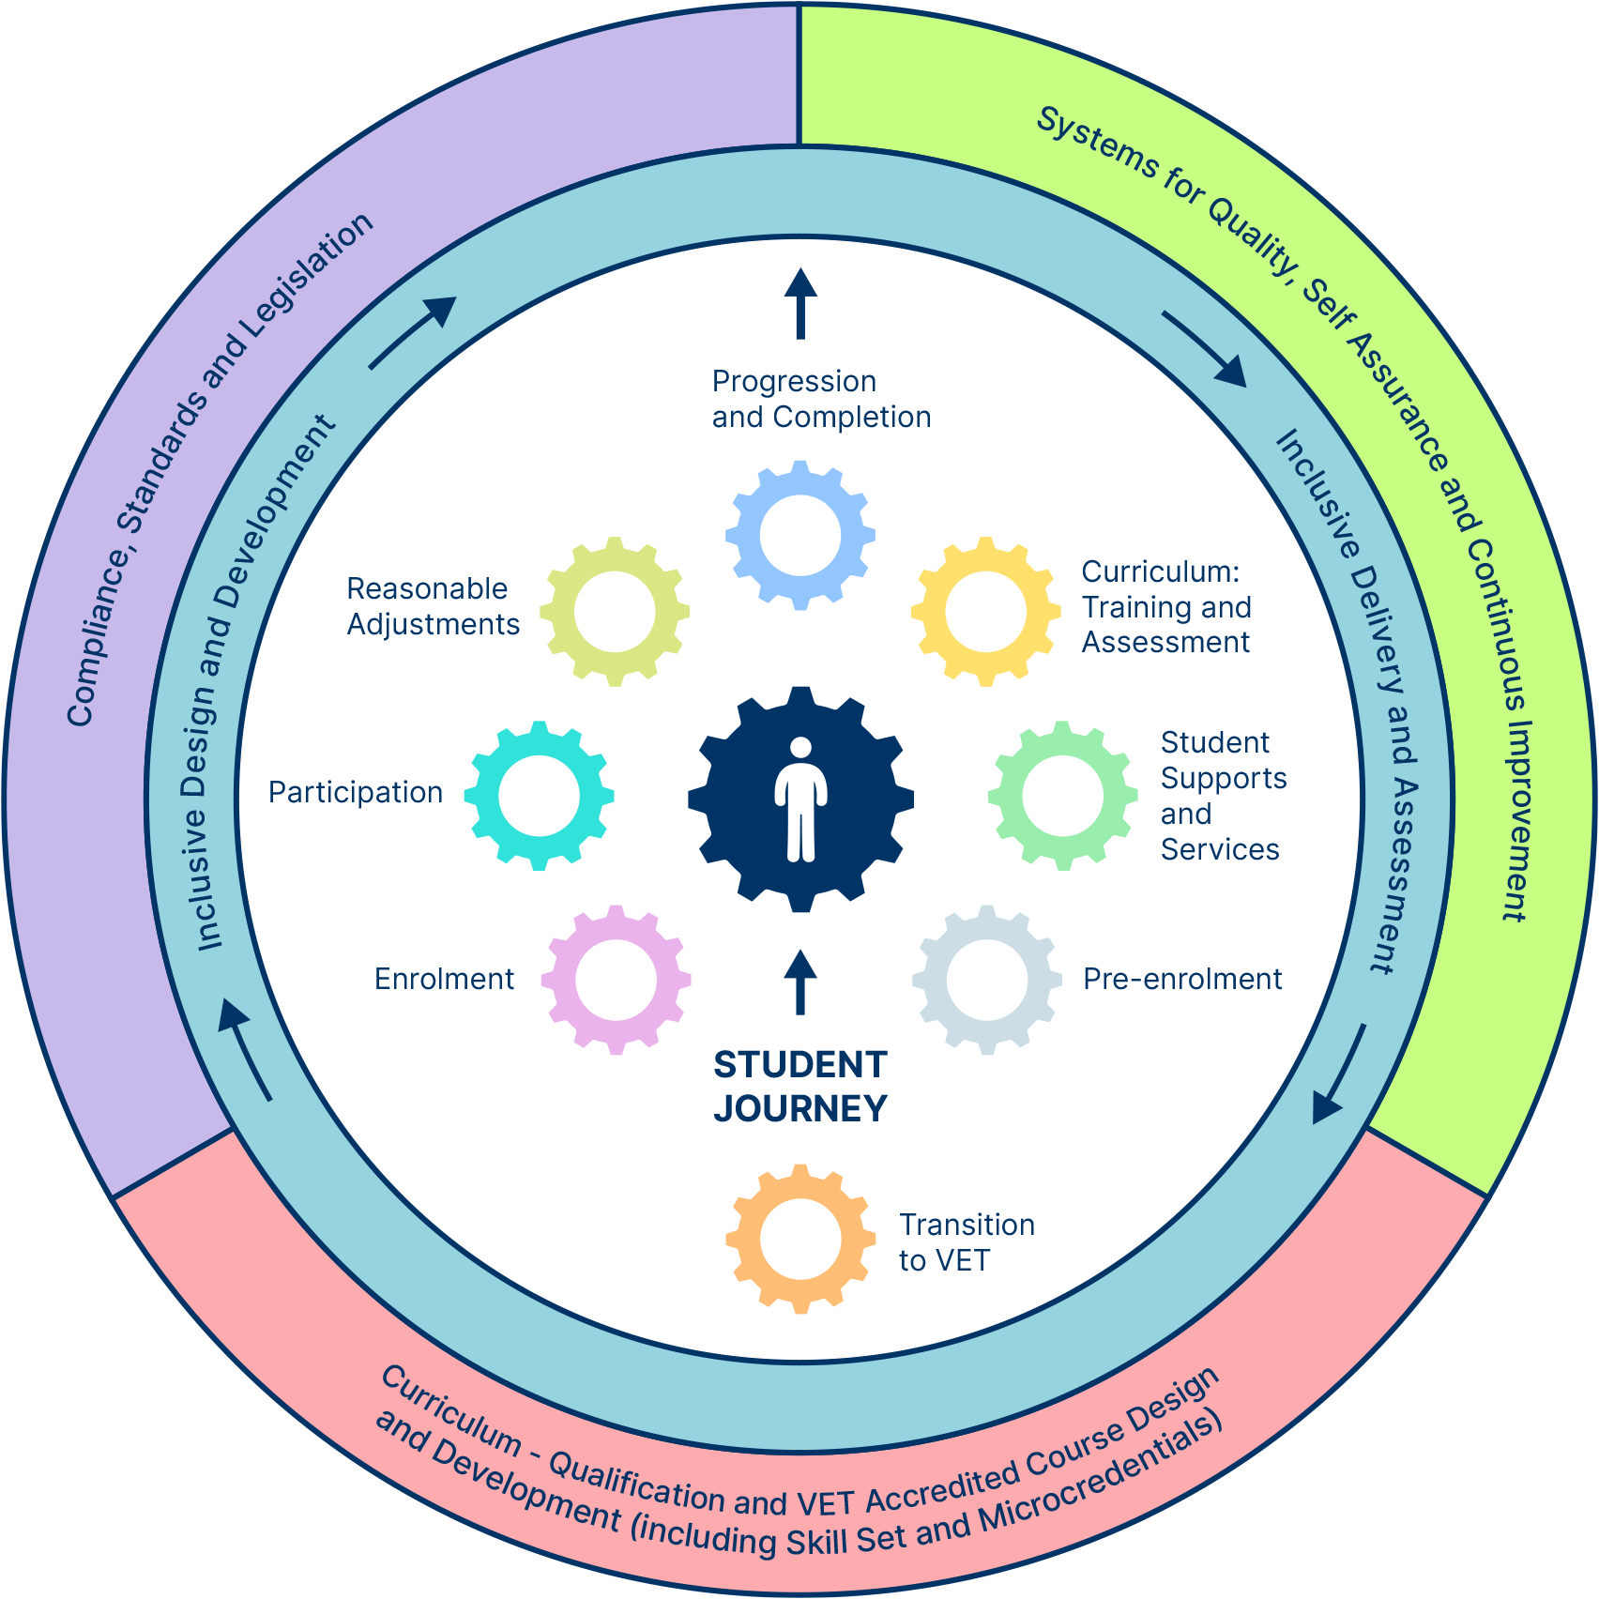

# Supporting Students with Disability in VET Toolkit

The Supporting Students with Disability in VET Toolkit is a range of resources to build capability and confidence in implementing inclusive practice, including:

* designing, developing and implementing accessible training and assessment
* consulting students with disability about their needs
* determining, documenting, implementing and monitoring reasonable adjustments
* continuously improving practice.

## Toolkit resources

The Toolkit resources are based on the [2020 Review of the Disability Standards for Education 2005](https://www.education.gov.au/disability-standards-education-2005/2020-review-disability-standards-education-2005/final-report), analyses of recent research and industry reports, the experiences of VET staff and practitioners, and guidance from sector specialists. The resources include practice guides, illustrations, self-checks, templates and examples.

### Practice guides

[Practice guides](https://www.adcet.edu.au/vet/practice-guides) are based on the key steps of the learner journey and aligned to the DDA and DSE. Each guide focuses on a specific step in the student’s learning journey. Each guide presents an overview of the practice, an explanation of the practice, practice considerations and checkpoints, and a summary of how they relate to the regulatory framework. They also recommend free accessible resources and training for RTO staff, trainers and assessors. The aim is to better support students with disability and for RTOs to meet their obligations as outlined in the DDA, DSE and Standards for RTOs 2015.

### Practice illustrations

[Practice illustrations](https://www.adcet.edu.au/vet/practice-illustrations) provide examples of situations that may occur for students with disability during their student journey in the VET sector. These illustrations guide and support RTOs and their staff, including disability practitioners, trainers and assessors, as well as those in administration and compliance/governance.

The practice illustrations show the links to the DDA, DSE and Standards for RTOs 2015. In addition, they aim to build the capability of RTO staff, trainers and assessors to understand their obligations under the DSE and confidently support students with disability.

### Practice self-checks

The [Trainer and Assessor Self-Check](https://www.adcet.edu.au/vet/supporting-resources) aims to help individuals reflect on and assess their responsiveness and capability to support students with disability. It also identifies the ways in which individual training and assessment practice supports the requirements of the DDA and the DSE.

The [RTO Self-Check](https://www.adcet.edu.au/vet/supporting-resources) aims to help an RTO to reflect on and assess the organisation’s responsiveness and capability to support students with disability. Like the Trainer and Assessor Self-Check, it also identifies the ways in which the organisation is meeting the requirements of the DDA and the DSE.

The self-checks cover each area of the student journey as they are aligned to the DDA and DSE requirements. The practice indicators should help prompt reflection, guide practice and professional development to build capability in inclusive education and training, as well as increase accountability.

### Templates and examples

[Downloadable templates](https://www.adcet.edu.au/vet/templates-and-examples) are available to illustrate how evidence of practice can be recorded and the ways in which an RTO might demonstrate how it meets the requirements of the DSE. For each template, there are exemplars of practice to guide completion. Templates can be adapted to meet organisational requirements.

# Glossary

An extensive glossary defines the terminology referred to in each of the resources.

**Alternative/accessible formats**: Material that has been reformatted to be accessible to people with a range of needs such as people with learning disabilities, people who are blind or vision impaired, or people who are Deaf or hard of hearing. Formats can include audio, braille, large print, Word format or tactile images.

**ASQA**: Australian Skills Quality Authority. ASQA is the national regulator for Australia’s vocational education and training sector.

**AVETMISS:** Australian Vocational Education and Training Management Information Statistical Standard. It is a national data standard which ensures the consistency and accuracy of vocational education and training (VET) information and covers the national VET data collections.

**Disability Access Plan**: A document used to record reasonable adjustments to enable equitable participation in learning for students with disability.

**DDA:** The *Disability Discrimination Act 1992 (Cth)*.

**Disability**: Disability covers a range of impairments, activity limitations and participation restrictions. Section 4 of the *Disability Discrimination Act 1992* *(DDA)* defines disability. It includes a disability that a person presently has, previously had, may exist in the future, or is imputed.

**DSE**: The *Disability Standards for Education 2005 (Cth) (DSE)* came into effect in August 2005 and clarify the obligations of education and training providers under the DDA. They were reviewed in 2010, 2015 and 2020.

**Easy Read**: Easy Read refers to the presentation of text in an accessible, easy-to-understand format. It is often useful for people with learning disability and may also be beneficial for people with other conditions affecting how they process information.

**Imputed disability**: A term used in the DDA. It means an undiagnosed disability that disability practitioners or educators may consider a student to have that is having a functional impact on their learning.

**LLND:** Language, literacy, numeracy, and digital competencies are often enrolment requirements gleaned from screening tests that must be done online before enrolment and funding are confirmed.

**Multimodal/multimodality**: Conveying something through multiple channels using different media or means of communication.

**Online learning platforms**: Used by RTO institutions for student services, delivery of learning content and resources for both students and staff.

**Reasonable adjustments**: Under the DDA and DSE, reasonable adjustments are measures or actions taken to help a student with disability to participate in a course on the same basis as other students. An adjustment is reasonable if it balances the interests of all parties affected.

**Standards for Registered Training Organisations (RTOs) 2015 (Cth)**: The *Standards for Registered Training Organisations (RTOs) 2015 (Cth)* are regulatory standards for RTOs and regulators. They aim to protect the interests of all students in Australia’s VET system. Compliance with the Standards is a requirement for most RTOs delivering nationally recognised training. **Please note:** Some RTOs in Victoria and Western Australia are regulated by the *Victorian Registration and Qualifications Authority* or the *Training Accreditation Council Western Australia respectively*.

**Strengths-based approach**: A strengths-based approach focusses on what the student is able to do and contribute, not what they are not able to do due to their disability.

**Student Support/Learning Plan**: A document the RTO uses to identify and detail any support needs the student might have.

**Success orientation**: A way of being and doing where the plan is for success of the individual and a positive mindset is the focus, identifying potential barriers but with a clear success goal.

**Training Accreditation Council (TAC)**: The *Training Accreditation Council* (TAC) is Western Australia's Vocational Education and Training (VET) Regulator and is established under the *Vocational Education and Training Act 1996*. The Council registers training organisations under the *Standards for Registered Training Organisations (RTOs) 2015 (Cth)* and accredits courses under the *AQTF 2021 Standards for Accredited Courses*.

**Universal Design**: The intentional design to maximise access for all people including people with disability.

**Universal Design for Learning**: An approach to minimise or remove access barriers at the design phase to maximise participation for all learners.

**Victorian Registration and Qualifications Authority (VRQA)**: The *Victorian Registration and Qualifications Authority (VRQA)* is Victoria's education and training regulator. It is an independent statutory authority that works to assure the quality of education and training in Victoria through the application of standards to education and training providers and accreditation of courses and qualifications.

**Web Content Accessibilities Guidelines (WCAG)**: Guidelines developed by the W3C that outline how to make web content more accessible for people with disability. [https://www.w3.org/WAI/standards-guidelines/wcag](https://www.w3.org/WAI/standards-guidelines/wcag/)

# Resources guide

A selection of key recommended resources is assembled to strengthen practice.

## Key references

* [Disability Discrimination Act 1992 (Cth) (DDA)](https://www.legislation.gov.au/C2004A04426/latest/text)
* [DDA guide: What's it all about | Australian Human Rights Commission](https://humanrights.gov.au/our-work/disability-rights/dda-guide-whats-it-all-about)
* [Australian Human Rights Commission (AHRC): Education and Disability](https://humanrights.gov.au/our-work/disability-rights/projects/education-and-disability)
* [[Disability Standards for Education 2005 (Cth) (DSE)](https://www.legislation.gov.au/Details/F2005L00767)](https://www.legislation.gov.au/Details/F2005L00767)
* [Disability Standards for Education 2005 Guidance Notes](https://www.education.gov.au/swd/resources/disability-standards-education-2005-guidance-notes)
* [Department of Education – Disability Standards for Education](https://www.education.gov.au/disability-standards-education-2005)
* [Standards for Registered Training Organisations (RTOs) 2015 (Cth)](https://www.legislation.gov.au/F2014L01377/latest/text)
* [Victorian Registration and Qualifications Authority](https://www.vrqa.vic.gov.au/VET/Pages/default.aspx)
* [Training Accreditation Council in Western Australia](https://www.wa.gov.au/organisation/training-accreditation-council/training-accreditation-council-regulatory-framework)

## DSE fact sheets

* [Fact sheet: Disability Discrimination Act 1992](https://www.education.gov.au/swd/resources/fact-sheet-1-disability-discrimination-act-1992)
* [Fact sheet: Disability Standards for Education 2005](https://www.education.gov.au/disability-standards-education-2005/resources/fact-sheet-2-disability-standards-education-2005)
* [Fact sheet: Parental engagement](https://www.education.gov.au/swd/resources/fact-sheet-3-parental-engagement)
* [Fact sheet: Effective consultation](https://www.education.gov.au/swd/resources/fact-sheet-4-effective-consultation)
* [Fact sheet: Making a complaint under the DDA and DSE](https://www.education.gov.au/disability-standards-education-2005/resources/fact-sheet-3-making-complaint-under-dda-and-dse)
* [Australian Skills Quality Authority Fact Sheet: Providing quality training and assessment services to students with disabilities](https://www.asqa.gov.au/resources/fact-sheets/providing-quality-training-and-assessment-services-to-students-with-disabilities)
* [ADCET (Australian Disability Clearinghouse on Education and Training)](https://www.adcet.edu.au/)

## Disability Awareness e-Learning platform

* [Introduction to Disability Awareness](https://disabilityawareness.com.au/courses/introduction-to-disability-awareness/)
* [Secondary Education](https://disabilityawareness.com.au/elearning/post-sec-ed/)
* [Orientation for External Support Workers in Tertiary Settings](https://disabilityawareness.com.au/courses/orientation-support-workers/)
* [Online Access for Tertiary Students who are Blind or Vision Impaired](https://disabilityawareness.com.au/courses/online-guidelines-blind-or-vision-impaired/)
* [Universal Design for Learning in Tertiary Education](https://disabilityawareness.com.au/courses/universal-design-for-learning-in-tertiary-education/)
* [VET Staff Supporting Students with Disability](https://disabilityawareness.com.au/courses/program-1-vet-staff-supporting-students-with-disability/)
* [VET Educators Supporting Students with Disability](https://disabilityawareness.com.au/courses/program-2-vet-educators-supporting-students-with-disability/)

#### Disclaimer

The 'supporting students with disability resources' provide guidance on legislation and policy for Registered Training Organisations (RTOs) regarding vocational education and training for students with disability, but they should not be considered legal advice or impose additional legal obligations. RTOs should seek tailored legal advice to understand their specific obligations. More information on this disclaimer can be found at [*adcet.edu.au/vet/disclaimer*](https://www.adcet.edu.au/vet/disclaimer) or by contacting *the* [Department *of Employment and Workplace Relations*](https://www.dewr.gov.au/).

This resource is funded by the Australian Government Department of Employment and Workplace Relations through the [*Supporting Students with Disability in VET project and is hosted by ADCET*](https://www.adcet.edu.au/vet).

1. Convention on the Rights of People with Disabilities: <https://social.desa.un.org/issues/disability/crpd/article-24-education>