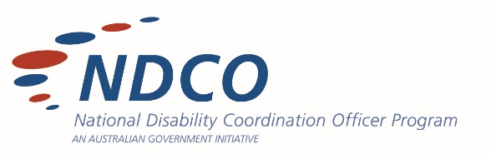

BRANDING GUIDE

LOGO
The Master Logo is the primary visual tool for Education Alliance Queensland (EAQ).
- The logo is to appear no smaller than 40mm width and 19m height.
- The logo maybe used in black. The white logo may be used when the background is dark; it may also be overlaid on a photographic image, provided the contrast is adequate.
The abbreviated logo may be used in conjunction with the Master Logo.
- It may be displayed no smaller than 15mm width and 10mm in height. This logo is only available as full colour.
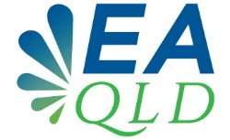

Process Colours
Blue: C100 M58 Y0 K21
Green: C64 M6 Y100 K0

Spot Colours
Pantone Blue: 7462C
Pantone Green: 7489C

File Formats
.JPG – use this format for both printing and web
.PNG – transparent background
.EPS – vector art file

TYPOGRAPHY
The two fonts that make up the visual aspect of the brand are Open Source fonts, selected on the basis of legibility, flexibility in weight as well as visual style.
Open Sans Extra Bold
Open Sans Semi Bold

The secondary typeface, Cormorant Regular is to be used for all ‘body’ text in marketing and presentations to harmonise the brand visually.
Produced by Testify Studio 2018

