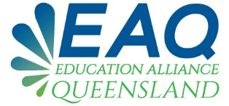

STRATEGIC INTENT

VISION
Education Alliance Queensland (EAQ) will foster seamless education, training and tertiary transitions for people with disability through collaboration and effective communication.

MISSION
Education Alliance Queensland (EAQ) will foster seamless education, training and tertiary transitions for people with disability through collaboration and effective communication.

GOALS
- Implement the EAQ model to enable collective impact and incorporate relevant stakeholders from all educational spaces and government departments.
- Implement the EAQ mechanisms for enhanced collaboration and relationship building amongst education professionals.
- Apply a continuous improvement framework to Educational Alliance Queensland thereby enabling a solutions-focused and innovative environment.

OBJECTIVES
- To provide a framework that will promote collective impact in action.
- Implement the EAQ mechanism for enhanced collaboration and relationship building amongst education professionals from the secondary school sector, alternate learning spaces, tertiary sectors and government departments linked and coordinated through the Queensland NDCO network.
- To ensure EAQ is solutions-focused with an innovative lens to provide the best possible inclusive educational experience from school to tertiary and beyond for people with a disability.

ACTION PLAN
- The Terms of Reference will provide a clear definition of:
- Education Alliance Queensland and what EAQ aims to achieve.
- EAQ Membership & Role; Stakeholders who will be involved.
- Meetings: Coordination – Frequency – TOR Review

The Action Plan document will reflect progressive activities planned and undertaken on an annual basis in line with the Strategic Intent and Terms of Reference of the Education Alliance Queensland.

