# UDL Symposium

## Inclusive Learning Brainstorm-Miro Board Contributions

**Scenario 1:**

**Student has a dyslexia and requires the ability to copy and paste electronic text into their assistive technology.**

**You are about to review and update the weekly learning resources for your unit. They are included as a PDF on your unit**

**Scenario 2:**

**Student is hard of hearing and requires transcripts for audio content.**

### Contributions

* Microsoft OneNote / Word Immersive reader:  
  1) Colour code parts of speech (synthesise information)  
  2) Immersive reader (customise voice and reading speed)  
  3) Built into latest update of MS Word.
* Remembering the role of the hidden curriculum, particularly in higher education. We can't assume knowledge, even with technology and terms that we are used to using.
* Microsoft Stream can create captions and a transcript. You just need to go through and check it is correct (particularly with subject-specific terms)
* Scenario One:   
  PDF's are notoriously tricky to work with. Microsoft OneNote with Learning tools (immersive reader) is my favorite for reading, synthesising information and organising work - however, the PDF would have to be accessible, or preferrably a Word doc..  
  I would also like to know more about why the student is having to copy and paste the content. Is it for reading?  
  Another alternative is to use Speechify. Speechify can read content and you can copy and paste the text from a PDF. Clunky, but doable.  
  Accessible Word doc is the most straightforward and easy to use format.  
    
  Scenario 2: Microsoft Teams has Transcript enabled. It would depend on the content you are using.  
  Shane L
* Barriers- time constraints of teacher and student technology
* CC should always be available by default
* Someone made a good point in the chat. It shouldn't matter what certain students need, UDL increases accessibility for all. Maybe we can focus on ways to present audio content in different ways?
* Enable subtitles within PowerPoint. Easy to use and benefits lots of people.
* This image of permanent, temporary and situational disability helps us to consider how all of us can experience barriers to learning at different times. [Link to the source of the image found here](https://www.iweb.co.uk/2016/10/inclusive-design-why-our-websites-should-more-accessible/).
* 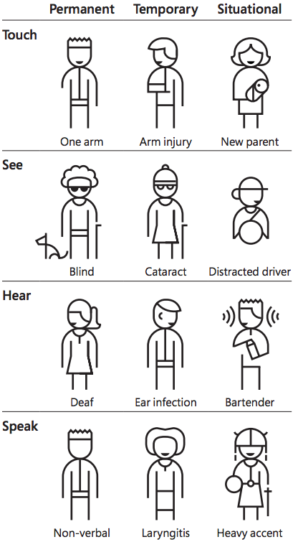
* Microsoft Stream can create captions and a transcript. You just need to go through and check it is correct (particularly with subject-specific terms)
* Talking about having trouble engaging with videos due to ADHD...Microsoft Stream lets you add chapters. SO HANDY to skip to the content you need. Especially if it is a recording of a lecture, you can quickly get right to the bit you need to review. You can also share a link to a specific chapter in the video (they will have access to the whole video, but it will start at the chapter.
* Where possible, provide content in multiple formats. Is there a video, a short piece of text or a podcast that cover the same topic?
* Focus on what you can achieve. Try something new each term or each month. UDL and inclusive pedagogy is a life-long journey of improvement
* Create accessible Word versions, and/or ensure the content is in an LMS - and is accessible, so the student can use Blackboard Ally or YuJa Panorama to choose what format they wish to use.  
  These accessibility tools provide a number of alt format options including conversion to mp3 file, beeline, immersive reader.  
  At our institution, we recommend all content is 'scripted' in Word first (includes LMS content, videos, audios, activities etc) which are all 'accessibility = good to go' so there is (as much as possible) always options for students and educators.  The work is done upfront.
* [This link from Vision Australia has a range of resources to check colour contrast and accessibility.](https://www.visionaustralia.org/business-consulting/digital-access/resources/colour-contrast-analyser)
* TextHelp has some good resources for online accessibility
* Remember how many students may not know they have specific learning needs. I didn't know I had ADHD until I was 30

